**Anne Jacqueline Hathaway**

Anne Jacqueline Hathaway was born in Brooklyn, New York on November 12, 1982. Anne is both an actress and singer. As an actress, she was ranked in 2015 as one of the highest paid in the world. She got her acting debut as a teenager in 1999 in the television series *Get Real* and by 2009 had been cited in *Forbes Celebrity 100.*

With a total credit of $6.4 billion to her movies in the box offices around the globe, she stands tall as an achiever and a global movie icon. As a singer, Anne Hathaway has featured in top soundtracks, winning an Emmy in the process for providing her voice tracks in *The Simpsons*.

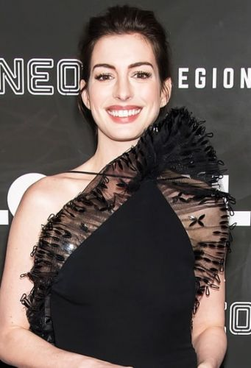

Anne’s parents are both originally from Philadelphia. Anne’s mother, Kate McCauley Hathaway was also an actress while the father, Gerald T. Hathaway, a lawyer. Anne shot to fame when she appeared alongside Julie Andrews and Heather Matarazzo in the movie The *Princess Diaries* (2001) and its continuation in 2004.

She played the role of a young girl who finds out she has royal blood. She also appeared in the cast of Nicholas Nickleby in 2002, after which in 2004 she secured the starring role in Ella Enchanted. With the success of the Princess Diaries, Anne had unwittingly created a family friendly image which did not go on too well with her.

So she set out to break out of the image by appearing topless in a couple of films namely *Havoc*(2005) and *Brokeback Mountain* (2005). She followed this up with a couple of interviews stressing that her roles in family-friendly films should not preclude her from taking on more adult roles including appearing nude in movies. She posted her nude photos in some media.



Anne’s most successful roles, apart from her role in the *Princess Diaries in chronological order include roles in Brokeback Mountain* (2005), *The Devil Wears Prada* (2006), *Get Smart* (2008), *Rachel Getting Married* (2008), *Valentine's Day* (2010), *Alice in Wonderland* (2010), *Love and Other Drugs* (2010), *The Dark Knight Rises* (2012), *Les Misérables* (2012), *Interstellar* (2014) and *The Intern* (2015).

Her performances in the roles have earned her a Golden Globe, an Academy Award, BAFTA Award and a Screen Actors Guild. In addition performances in several films have earned her the informal title of the hottest young actress in Hollywood and is perceived to have high sex appeal.

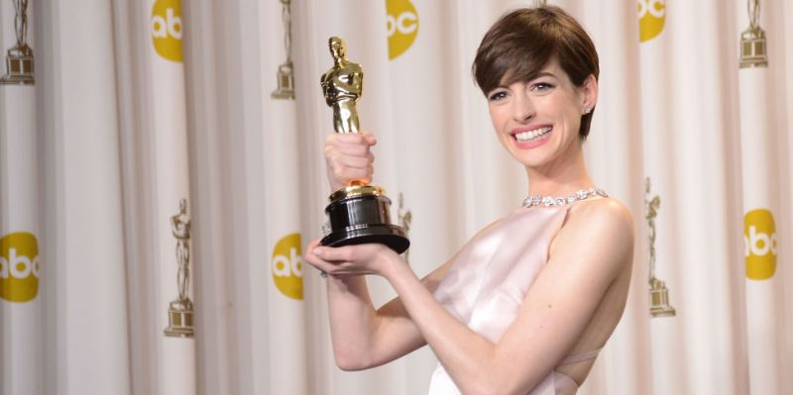

This has led to business houses pursuing her for promotional contracts. Several cosmetics companies have approached her and in Jan 2008 she signed up with the giant French perfume and cosmetic company Lancôme to be the face of their fragrance Magnifique. She also signed up with the Italian company Tod's in 2011 as the face of that company.



Anne plays significant roles offstage supporting charities and good causes. She is particularly fond of her role as a board member of the Lollipop Theatre Network. This is an organization that seeks to improve the health outcomes of children in hospitals by bringing films to them.

In addition, she is an advocate for NIKE Foundation in the quest to raise awareness of the evils of child marriage. She has travelled extensively to countries such as Ethiopia and Kenya fighting for the rights of young women and girls. Her activism in the discourse of gender equality has not gone unnoticed by the United Nations who have since appointed her as a UN Women goodwill ambassador.

With all this success and glamour one would have thought she would be adored by everyone, but not so with Anne Hathaway. She has a big following of ‘Hathahaters’. These are a group of non-fans and critics who see her as inauthentic and believe she resembles a performer in a high school drama who cannot return to her real self away from the stage.

A well-known author specializing in Hollywood culture, Neal Gabler is quoted as having commented as follows: “We love authenticity, that’s why we have a billion reality shows, and here comes Anne Hathaway. Everything she does seems managed, calculated or rehearsed. Her inauthenticity — or the feeling of her inauthenticity — is now viral.”

Anne was married to Adam Shulman, a Jewish businessman in a traditional Jewish ceremony in 2012. They now have a son, born in 2016. Before Schulman Anne had a romance with an Italian, Raffaello Follieri. An Italian property developer. However Follieri fell foul of the law in his business deals and was jailed in 2008. However, just a couple of months after this scandal rocked the world of Anne, much to the delight of her fans, she was nominated for a Golden Globe.